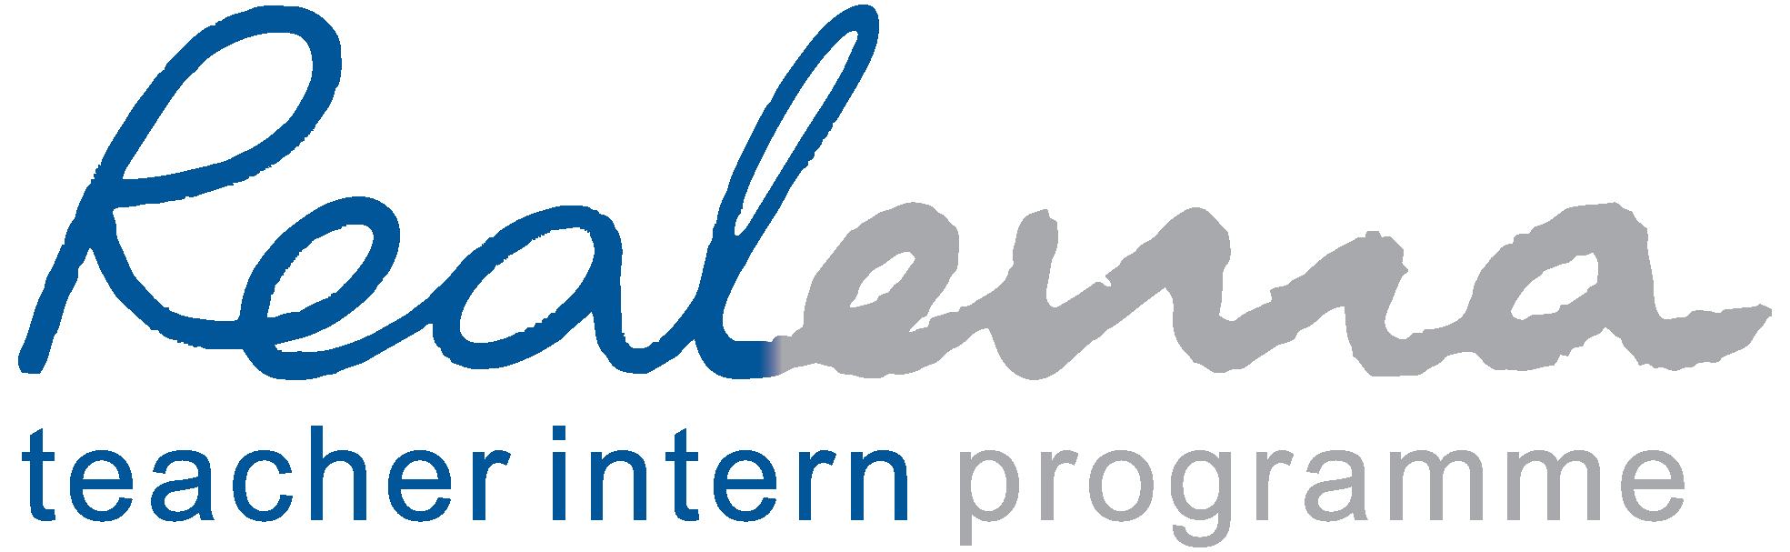
COSTS & COMMITMENTS
Background
Realema offers bursaries to deserving and suitable people of colour from vulnerable communities to study for a teaching degree while gaining full-time best-practice work experience at top schools. This enables students to escape the poverty cycle by forging sustainable careers in teaching while developing the professional teachers that South Africa needs.
Bursary offering
The bursaries include:
- University fees and books
- Includes administrative assistance such as applications and registrations, ordering and delivering books, physical portfolio submissions, intervening when problems persist at universities, and arranging and funding out-of-town tutorials and related accommodation.
- Accommodation support (in 2026, R1 300/month for interns not accommodated at schools)
- Internship stipend (usually paid by partner schools)
- Laptop and IT support
- Individual academic tutoring
- Professional psychological counselling
- Comprehensive and multi-layered mentorship
- Life skills workshops, e.g., financial management, workplace readiness and time management
- Assistance with medical insurance
- Assistance with CVs and applying for teaching posts after graduation
General partner school commitment
To gain best-practice experience, interns should become fully integrated into the teaching faculty and the academic, sporting and cultural lives of Realema’s Partner Schools where they are placed.
ITEM | PARTNER SCHOOL'S COMMITMENT | REALEMA'S COMMITMENT
University fees and books |  | ✓
Internship stipend | ✓ R5 000/month with accommodation or R7 000/month without accom. | ✓
Accommodation and data | ✓ If available. In boarding houses, interns can do boarding duties. | ✓ R1 300/month if no accommodation at school
Mentor Teacher | ✓ Intern's class teacher
Professional development | ✓ As per other staff members
Laptop and maintenance |  | ✓
Academic tutoring |  | ✓
Psychological counselling |  | ✓
Mentoring |  | ✓
Occasional intern gatherings |  | ✓ Ad hoc – prior notice given to PS
Life skills workshops |  | ✓
Medical insurance | ✓ Payroll facilitation (no expense) | ✓ Reimburse 50% to intern
CV assistance in final year |  | ✓
Intern manager–Realema meetings | ✓ Short, regular meetings, e.g. fortnightly or as arranged. | ✓ Fortnightly, or as arranged, online or in-person
Incidentals | ✓ Coaching kit, etc. +-R1 000/month | ✓ Compassionate support as needed.
Total/month/intern | +- R8 000/month
Total/annum/intern | +- R96 000

